CompanyABC Due Diligence Report Summary

InvestorFundXYZ

Mysty Rusk & Fellow DD Partner

July 2017

This due diligence report is an abbreviated review of previous due diligence efforts provided by other investor groups.
CompanyABC is a fintech SAAS broker that connects fintech developers with banks and credit unions to create a variety of white label applications targeted at millennials.

Market Opportunity
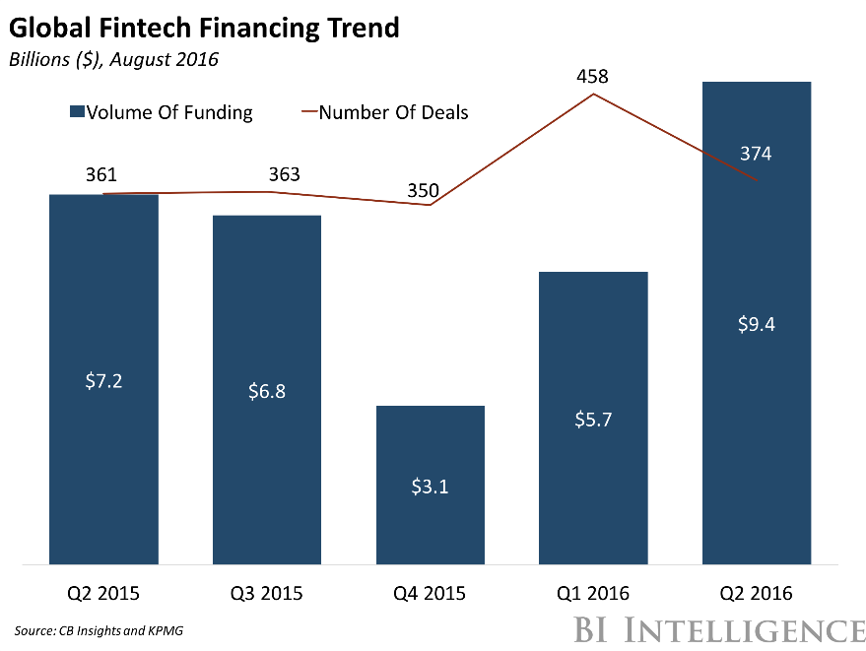
CompanyABC reports the total available market in 2015 at $3.6B. Independent research found a Business Insider article that demonstrates fintech is a fast growing market, and confirms the market size at $3.1B growing to $9.4B in 2016.
There is a large addressable market supported by trends and the “big banks” current investment in fintech apps ensures an informed/educated market for similar solutions exists.
CompanyABC’s solution doesn’t rely on a single product to succeed. Instead it positions itself to represent numerous solutions benefitting from the “winners” and minimizing risk and protecting itself from the losers. Most customers will understand the value proposition and CompanyABC faces normal sales challenges.

Investment Opportunity
The pro-forma cap table (attached), is based on the information provided by CompanyABC. If INVESTORFUNDXYZ invests $100,000 we would own 1.28% of the company. The high-end revenue projections provided by CompanyABC appear aggressive and may overstate the opportunity based on the Company’s current product lineup.

Below is a more conservative projection:
- Total target users: 100,000,000 customers (per prior Due Diligence report and Business Plan)
- Assumed penetration: 10.0% - this is a total estimation but we assuming the use of an alternative bank app (like the ones they will be offering) are not widely used amongst a high number of bank customers on a regular basis – 10.0% would be a great rate of penetration
- Revenue per month per user: Assume 50/50 split between 3rd party apps (CompanyABC nets $0.10) and CompanyABC apps (CompanyABC nets $0.45) = $0.275/month/user
- Total net annual revenue: (100,000,000 *10.0%) * ($0.275/month * 12 months) = $33,000,000/year
This high end projection is lower than CompanyABC provided ($33MM vs. $243MM in BP for 2021). However, if they were to get to $33MM/year, we could reasonably assume a valuation of $150MM (~5x revenue) which would yield a very attractive return for the Fund. CompanyABC’s revenue projections are very aggressive but the market is growing and large enough to yield a great return for the Fund even if they hit 10% of their goal.
This is a hot investment area with room for more offerings. There is strong evidence of similar investments and the company is positioned to generate positive returns for outside investors. CompanyABC is likely to be acquired if they deliver on a few identified milestones.

Technical Solution
As will any software solution there is not a component that is generally patent-able, trademark-able or a candidate for other considerable intellectual property protection. Platform as a service (PAAS) is a new take on traditional SAAS and CompanyABC’s solution is unique in that it coordinates the best offerings of many developers for a very specialized target market.
There are high barriers to entry in fintech and generally tools used by financial institutions. Because CompanyABC has expertise in this area, they are uniquely positioned to take advantage of this barrier. By acting as a clearinghouse and intermediary for multiple developers, they will be able to see which products and developers are in greatest demand, best rates of return, etc. and whether they purchase those apps from the developer or not, they will share in the proceeds.
Elegant solutions that emerge through this process will become “must have’s” from financial institutions that wish to remain relevant with millennials.

Business Model
The business plan is thorough. There is a clear customer acquisition plan and the related costs are reasonable. Big banks are already paying for or committed to buying fintech applications with some degree of success in reaching millennials, so there is evidence that smaller banks and credit unions will follow suit.
There is a reasonable marketing plan in place and a demonstrated method for customer conversion and retention. By focusing on the organizations that serve banks and credit unions, CompanyABC has developed an efficient distribution mechanism. There are sufficient economies of scale that will lower the incremental operating costs and by using white labeling and working with multiple developers, the cost to create new products and deliver them to market will become lower over time. The collection of user data for future app development also positions CompanyABC to create ongoing UVP in the fintech space. The financials, although overly positive and potentially inflated, even with considerable room for error, have a positive and compelling outlook. The use of funds is reasonable and outlines reachable milestones focused on scaling the business.

Team
The team members have extensive industry related experience. Several key team member have startup experience. Most of the team is in place and has worked together before. The CEO demonstrates ability and confidence, is focused and has an executable plan to achieve results.

Next Steps
According to Will Fowler, “Due diligence cannot pick a winner but it can weed out losers.” Based on the information provided and what has been verified outside of this process, CompanyABC does not appear to be a loser. The Due Diligence team recommends the full membership review the information provided by CompanyABC and invest $100,000.

